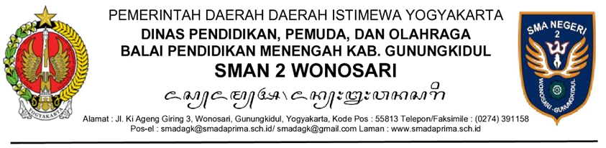

Nomor : ${nomor_naskah} ${tanggal_naskah}
Sifat : .......
Lampiran: ....... berkas/lembar
Hal : .......
Yth. ................
.......................
Dengan hormat,

Kami mengharap kehadiran Bapak/Ibu/Saudara dalam pertemuan yang akan diselenggarakan pada
hari, tanggal: ......, ..............
pukul : ....... s.d. …....
tempat : ......................
acara : ......................
Atas perhatian Bapak/Ibu/Saudara, kami sampaikan terima kasih.

Hormat kami,

Kepala SMAN 2 Wonosari,

${ttd_pengirim}

Drs. Tiya, M.M.

Tembusan:
1. ...........
2. ….......

Catatan:
Salam pembuka dan penutup sifatnya tidak wajib.
Lampiran Surat .................
Nomor : ...........................
Tanggal : ..........................

DAFTAR PEJABAT/PEGAWAI YANG DIUNDANG

- .......................................................................................................
- .......................................................................................................
- .......................................................................................................
- .......................................................................................................
- .......................................................................................................
- .......................................................................................................
- .......................................................................................................
- .......................................................................................................
- .......................................................................................................

Kepala SMAN 2 Wonosari,

${ttd_pengirim}

Drs. Tiya, M.M.

